**Group Three Project Report: Cultural Map of Edinburgh**

Group members:

Xinyan Chai, Yeru Lin, Ziyu Yang, Wenyun Deng, Zihan Yuan

Data-holder: Currie Morgan

**Introduction**

Edinburgh is a city with a rich cultural history. In our project, we looked at the cultural data of Edinburgh. Motivated by the broad art scenes of Edinburgh, we conducted a detailed analysis of the art of Edinburgh from the public art datasets. We've explored various techniques including both programming and physicalization in the process, and used both digital and physical methods to present our final visualization for the public art data of the city. Python and Arcgis were used to do the data analysis. By presenting our prototype which includes the 'Edinburgh Art Time' physical map and a digital interactive website, we hope to communicate the rich cultural heritage to the visitors of Edinburgh.

**Context**

According to Andrew, public art is place-based and representing the local history, which could serve as gathering places and promote collective memories (Zitcer and Almanzar, 2019). Public art visualizations could help people understand the public art, foster relationships between individuals, communities and the environment. Visualizations of cultural data at Edinburgh has had various design precedents. Previous predecessors have produced virtual tours and flaneurs for the city (The Edinburgh Culture and Community Mapping Project, 2020). We propose that a combination of a physical piece and interactive installation might accompany those visualizations and create another dimension for the projects. We found maps to be a good way for showing the position and give an overall view for the city. Some cultural data sets offer insights into the different cultural aspects for the city to construct our representation for the public art at the city.

**Data analysis**

We received data about various cultural statistics from our data holder. A first glance at the different statistics offered us insights for the cultural spaces of the city. Motivated by the art scenes in Edinburgh, we chose to focus on exploring the public art data sets and aims to probes and present some visualizations tailored to our findings and insights. Following our chosen topic, we used python to analyzed the public art data from 3 different aspects, including the development of public art over time, geographical distribution and material usage.

It is showed that, in general, there are 152 public art in Edinburgh in total. The earliest one existed in 1685, called ‘Charles II’, which has a history of more than 300 years. Four public art existed in 2020, including ‘Scotland, together, persevere, NHS’,’ Free Speech’, ‘Unity’ and ‘The Protest’. After that, we analyzed more details about the development of public art in Edinburgh over time. It is illustrated by the bar chart, the 20th century saw the most public art established in Edinburgh, accounting for 40.1%. While public art before the 19th century made up only 1.3% of the total. From 18th century, the number of newly established public arts increased during each century. Although it is only the first decade of the 21st century, 43 new public art projects have been created, accounting for 28.3 percent of total.

As is shown in the geographical distribution heat map and the location scatterplot, public art is not evenly distributed in Edinburgh and there are some areas where the density of art is huge and some areas where the density is scarce. It could be seen that the data is mainly concentrated in the city center area in Edinburgh. For the type of the public art, the data set offers us information about the specific type. Using Wordcloud, we find that the public art in Edinburgh is varied, including sculpture, statue, stone and monument.

**Target Audience**

We identify our audience to be the visitors to Edinburgh, and we hope to raise people’s interests and encourage people to further explore the public art in the city, finding their own serendipity of art encounters when wandering in the streets, and getting immersed of the art atmosphere of this city.

**Prototype**

Following our created maps from the data analysis process, we decided to present the year and location of public art in our physical map and use the digital map to show the accompany specific information of different art works. Combining both physical and digital techniques could help us to provide an informative and engaging experience for our audience.

Physical map:

In the process, we used sketches to go through our initial iterations. After importing the digital map from python to Adobe Illustrator, we found the main problem was that the points were too concentrated on the center part of the whole city so made the design choice to show the City Center in a separate map on the right-hand side of the city map to tailor to the traits of the data.

Making use of the laser cutting, we were able to customize the shape of the boards and layer boards to give more variations of our physical map.

Since the arts are concentrated in the City Center area of Edinburgh, our main visualization in the physical map is the time range of different art pieces at City Center. At first we decided to use the height of the sticks to represent the year range , since the sticks were a bit too dense and the height itself might not be enough to show the differences clearly to the audience, we made the design choice to use color along with the height of the stick to represent the year range for the specific art works from before 1800 to after 2000. The older the art, the higher the stick. Blue sticks represent art that appeared before the 1700s, red represents the art that built in the 18th century, and yellow and green time continues to approach the present.

Edinburgh as a whole is much larger, so we wanted to put some more holistic information on it. We chose to use plasticine of different colors to physicalize the heatmap to show the density of art in Edinburgh and the spatiality of the art. To make it more intuitive and three dimensional, we chose to overlay them. Different colours of the plasticine represents the density of the art at the city, while the red represents the most art-dense place and the blue represent less art-dense place.

For the year of art production, we were able to layer up different amount of boards to show different proportions to reappear the pie charts, which shows the time distribution of different art works. For instance, it can be seen that there were 40.1% of artworks arose in the 19th century.

Interactive screen:

When interacting with our device, the user will see the website first, and then see the instructions and have a first understanding for our product. We also created an interactive timeline of art, which aimed to provide intuitional information to accompany the physical map when presented to the audience. People can click on the name of the artwork on the timeline to see its picture and information, which can help them better see the distribution of the art and their richness in the time dimension. In this way, audience could be attracted, and continue to see the more general information following the webpage. We then put some charts that visualize the year of distribution, the location scatterplot and existing date distribution of arts to show the general view of our key findings of the map. When the mouse moves over the area of the chart filled with color, the corresponding data is displayed.

At the end of the webpage, we also presented Heatmap and Arts Position map for visitors to interact with and both maps allow them to zoom in and zoom out. When people slide the mouse wheel on the heatmap, the distribution of art in Edinburgh can be shown, while the other show specific positions of arts within mouse click on it. Thus, people can have a better understanding of the spatial distribution of these artworks, and can also relate them to some geographical or cultural environment. The different art forms in the city are shown via the ‘wordcloud’ .

In the video, we also imagine the scene that when people touch the top of the stick, the timeline will switch to the corresponding artwork whin its information to create a better using experience..

**Summary & Reflection**

Using data analysis we find that the art in Edinburgh is very rich and has a long history. We conducted analysis for the art in the different places and found that large amount of data concentrated on the main area of City Center. So we chose to present City Center separately along with the whole map of Edinburgh. While introducing about the time and location for Edinburgh, We also introduce the specific information of different art using both physical map and interactive website.

For some reasons, we made some slippers, such as the limited size of the map floor, so we chose to show only the art works in the city Center area in detail.In the future, we may add some Arduino modules to the physical Map to achieve interaction.In future work, we would like to explore how to take our prototype further using Arduino and improve the interactivity of our device.

**Reference**

Edinburghculturalmap (2020) *The Edinburgh Culture And Community Mapping Project*. Available at: https://www.edinburghculturalmap.org/research (Accessed 6 December 2020).

Zitcer, A. and Almanzar, S. (2019) 'Public art, cultural representation, and the just city'. *Journal of Urban Affairs*, 42(7), pp.998-1013. doi: 10.1080/07352166.2019.1601019

**The appendix**

Figure1

The amount of arts for different years

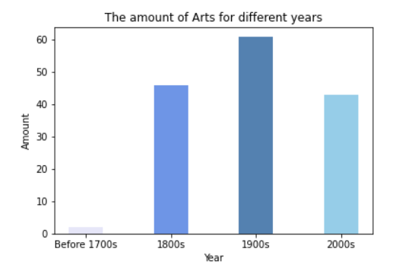

Shows the general number of arts in different years.

Figure2

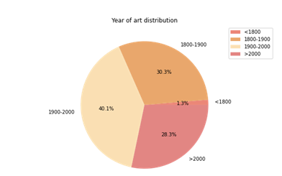

Shows the ratio of the number of artworks appearing in different years

Figure3

Public art heatmap

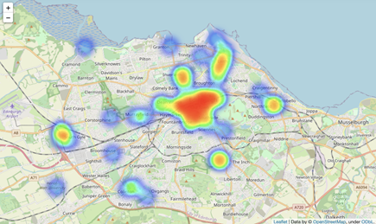

Displays the spatial density of the artwork.

Figure4 Physical map

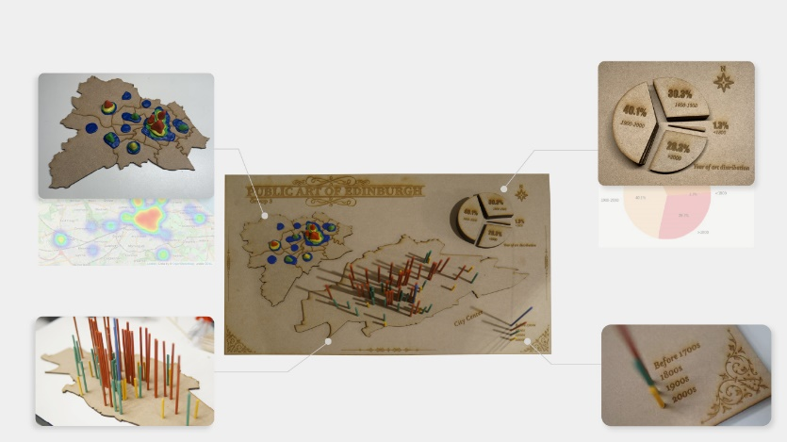

Zoom in the various parts of our map

Figure 5 Art position

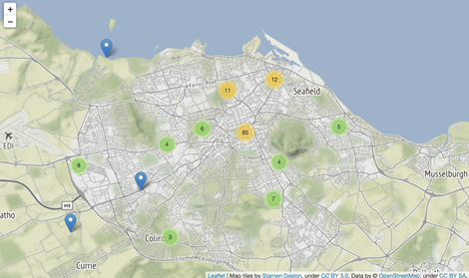

Shows the general positions information of arts in different centuries.

Figure 6 Wordcloud for art types

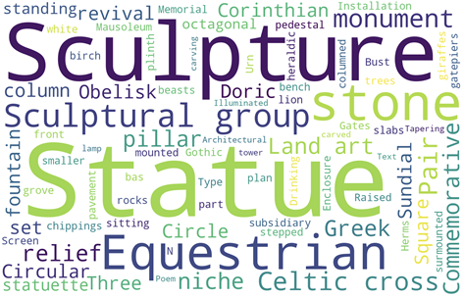

Shows the most art form in Edinburgh.

Figure 7 Location scatterplot

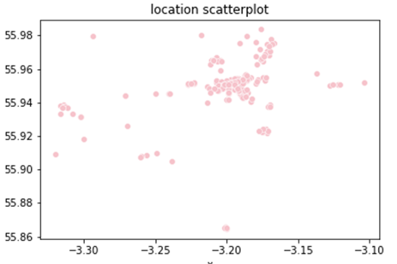

Shows different public arts in Edinburgh’s space distribution.